Class For Node Function for display
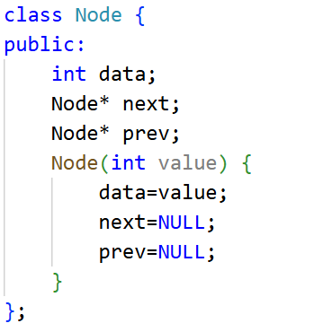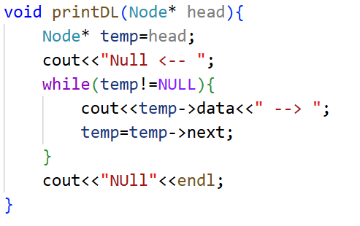

- Modify insertAtPosition() to handle inserting at the last position without using insertAtEnd().
CODE:
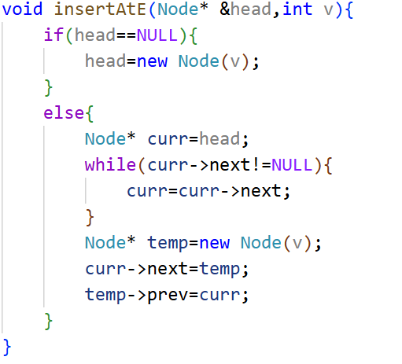

Output:
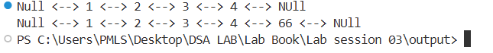

2. Write a function to count the total number of nodes in the DLL.
CODE:
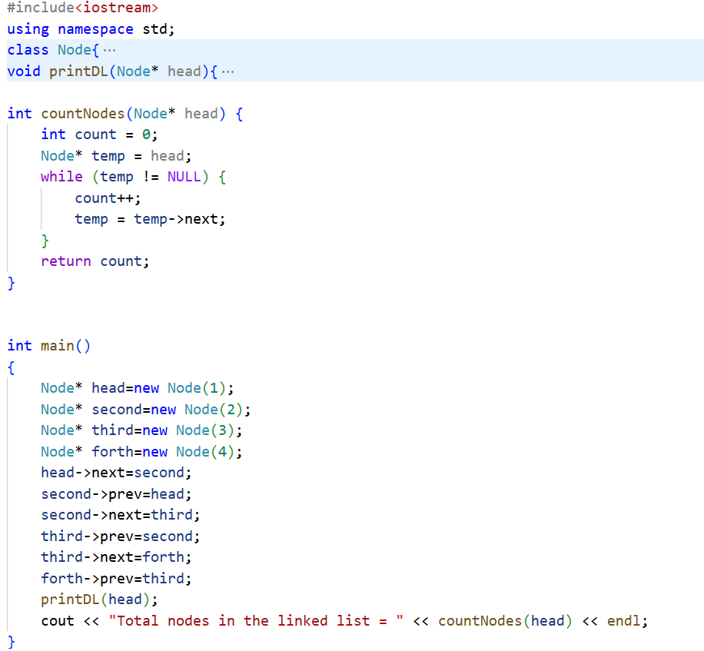\

Output:
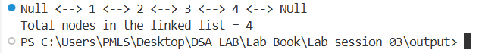
- Implement a function to reverse a doubly linked list:

CODE:
void reverseDLL(Node*& head) {
if (head == NULL || head->next == NULL)
return;

Node* left = head;
Node* right = head;

while (right->next != NULL)
right = right->next;

while (left != right && left->prev != right) {
int temp = left->data;
left->data = right->data;
right->data = temp;

left = left->next;
right = right->prev;
}
}

OUTPUT:

